Spomenik: Monument
Jim Kosem  Spomenik  1 Stepney City  49 Clark Street, London, E1 3HS, UK  jim@jimkosem.com | Dave Kirk  Mixed Reality Lab  University of Nottingham  Wollaton Road, Nottingham, NG8 1BB, UK  dsk@cs.nott.ac.uk

ABSTRACT

Permission to make digital or hard copies of all or part of this work for personal or classroom use is granted without fee provided that copies are not made or distributed for profit or commercial advantage and that copies bear this notice and the full citation on the first page. To copy otherwise, or republish, to post on servers or to redistribute to lists, requires prior specific permission and/or a fee.
CHI 2010, April 10–15, 2010, Atlanta, Georgia, USA.
Copyright 2010 ACM 978-1-60558-929-9/10/04....$10.00.
Spomenik is a design for a networked monument exploring spatial memory and relational geography, it is a bespoke networked monument which will explore the repurposing of digital records as a pervasive media experience. The work is intended to commemorate the tens of thousands of victims of Stalinist purges in post-war Slovenia and Yugoslavia. As a form of Pervasive Monument it allows us to explore issues of place, space, narrative and the longevity of records and their interactions with the digital.

Author Keywords
Spomenik, Monument, Memorial, Pervasive, Networked

ACM Classification Keywords
H5.m. Information interfaces and presentation (e.g., HCI): Miscellaneous.

INTRODUCTION
Spomenik (Memorial) is a physical expression of place, memory and narrative, more specifically, spatial memory and relational geography. This project looks at the notion of the stories places tell in the context of mass graves spread throughout Slovenia. In 1945, the then Socialist Federal Republic of Yugoslavia set upon a program of purges of political opponents and undesirables to solidify control upon the end of World War II, resulting in up to 400 known mass grave sites holding tens of thousands (exact figures aren’t known) [1] of people who’s stories were tragically buried with them. Under Yugoslavia, and until its disintegration and Slovenia’s subsequent independence in 1991, talk of the purges and graves was largely forbidden and their existence officially denied.
Slowly, nearly 20 years later and 65 years after the fact, the stories are starting to come out, accompanied by some little acknowledgement of the injustice and horror that took place, but for many, this is not enough. “Spomenik” seeks to respond to these issues. Most importantly, Spomenik conceptually does not seek to place blame, but rather encompasses a call for recognition and reconciliation, working with permutations of memory, place and narrative to achieve its means.

Memory
Memory is very spatially oriented, both in terms of physical, three dimensional objects, as well as the spaces formed around us. We as human beings feel an overwhelming need to keep memory alive, in a way providing the impetus to remember deliberately, we do this through both artefacts (objects) of memory and talk (such as narrative and storytelling), using things in discourse to keep them alive. We need to keep records, records of events to keep those events alive. We likewise form memories around places. “Place memory,” [2] or the forming of social identities around particular sites of events and their remembrance, may come to the fore again as a way of negotiating this memorial landscape, much as it was done before modern states started drawing almost arbitrary borders over the past 200 years. However, “when the past is no longer obviously connected to the present, memory becomes of diagnostic importance” [3]. Perhaps, we should just learn how to create our own places as easily as we create and retell our stories.
Just as we can and need to create places, the past becomes a place we can visit [4], because it is, in essence, an “instantaneous configuration of experiences” [5]. Just as you can recreate an experience, you can also recreate a place. Place is therefore, also transitional and transferable. With the modern phenomena of people, groups, and to an extent, entire communities on the move, housing and the very notion of home itself is more and more provisional. Likewise, so too can monuments, as physical expressions of groups and their memories, be equally mobile. With much of this transitory phenomenon being dependent on technology, particularly communications and network technology, it could best suit people who are always on the move, and in a sense in-between places, to have places brought to them.

Place
Place might be “whatever stable object catches our attention,” [6] but a place need not only be physical, for it can just as easily exist in a memory, a moment or a glance. A place is just as equally a pause [ibid]. That pause, that reflection shining through the predawn haze and the murky grey makes it something. For that split second you are somewhere. For that split second, where your mind, whether now or a priori from a decision hundreds of years ago, decided that something had value. Something pulled it out of the void of time and space and gave it something. It gave it somewhere to rest, it gave it meaning [7]. “Primary and Immobile,” [8] as Louis Marin says. As immobile as a gravestone, and just as personal.

Narrative
We are our stories [9]. Our personal “acts of narration not only represent, but also realize theories of self and world, and these theories are not confined to the past, but guide present and future understandings and behavior as well” [10]. Thus, we are doomed to be the bearers of history, trudging along under its constant weight and watch. As the eternal optimist Marx puts it, “The tradition of the dead generations, weighs like a nightmare on the minds of the living” [11].
The answer might lie in “narrative as [a] coherent sequence [which] makes history or experience comprehensible” [12]. The twists and turns of a good tale wrap around the reader/listener because the teller knows how to lead them along, and how make them relate. “Part of this experience of following involves a re-contextualization of the narrative imagery and events in terms of the listener’s own life experience” [ibid]. Thus, stories, whether our own or someone else’s, are a way for us to understand and empathize.

A Design Challenge
How do we collectively remember and how is this best expressed spatially? How do you design for mass death, injustice, and truth literally buried in the ground? How do you design for competing histories and grudges and feelings as fresh today as they were over 50 years ago? How does this relate to our (post) modern world where place itself is transitional?

The Design
Spomenik is a network of remembrance as expressed through mapped mobile access points recreating a macro-geography in the urban environment. Spomenik is thus inherently mobile and relational, and instead relies on a technological and narrative framework rather than on concrete and steel to express memory. So therefore, it is more of a framework, an emergent network of distributed stories and places. This framework designed so that the narratives kept hidden for so long would be provided by those and the loved ones of those who were victimized. With a web interface to maintain and provide the content (see www.spomenik.org ), and a locale-dependent, physical output, it would be distributed in every sense of the word, being non-hierarchal and distributed both geographically and structurally. It is inherently moveable as well, because physically it is nothing more than a network of small, easily deployable networked objects, meaning it could be in a gallery space, city center or public park.
Spomenik is physically expressed on the street level through many access or remembrance points which relate geographically to physical places elsewhere. Known mass grave sites (which might be scattered across a country) are mapped and scaled down to fit within a cityscape. In (re)creating a layered geography in the general public’s urban space, Spomenik utilizes the power and spectacle of architecture as the constructed environment to achieve scale and prominence, both visually and experientially. By seeing and experiencing so many loaded memorial objects, the viewer, whether active or passive, immediately begins to grasp the scope.
As a platform, Spomenik is meant to publish and push stories out of the ground far away where they have been buried to those that either may not know, or that don’t want to hear. As a system, it is there for those who have suffered, for them to have a bottom-up way of expressing their remembrance with their own means and of claiming and making known their history.
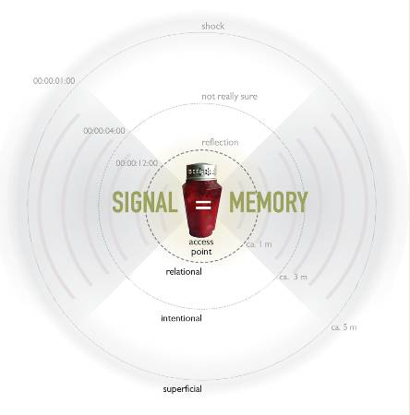
Figure 1. Conceptualisation of Spomenik
The use of grave candles and markings is significant in central and eastern Europe. These particular candles, almost always red (as seen in figure 1), are widely used to mark death sites and graves, and can be seen everywhere from on the sides of roadways to mountain crevasses. They always represent death. We may therefore choose to use such culturally-loaded artefacts with their already determined associations as the access points for our digital memorial content.
In the following paragraphs we will try to give a sense of how Spomenik might work as an interactive experience.
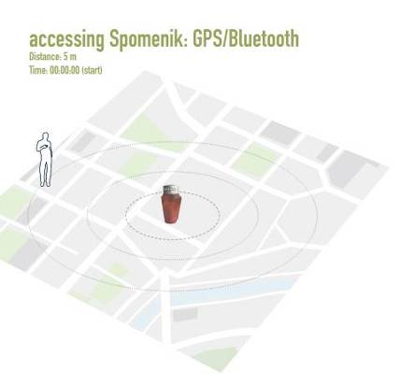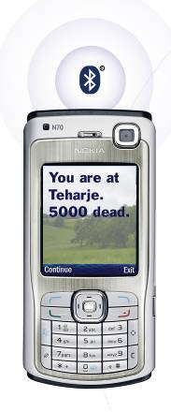Figure 2. User experience stage 1

A user approaches the access point and upon entering and approving, access is presented with the location of the ‘place’ and the number of dead there. The User – therefore running a client application ‘stumbles’ over a ‘mass grave’.
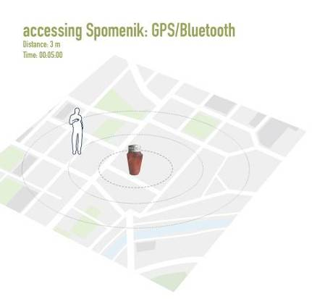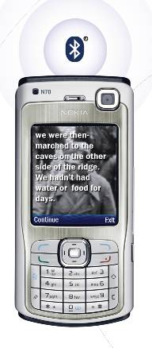
Figure 3. User experience stage 2
With reduced distance to the memorial, the software displays a picture (if available) of a victim executed at that ‘place’ and any story attached to the victim.
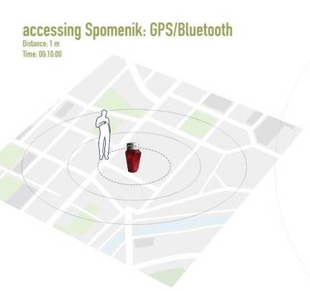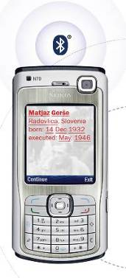
Figure 4. User experience stage 3

Finally, when within close proximity or otherwise next to the access point a final level of intimate narrative, their name, surname, place of birth and where and when they were executed is revealed to the user. Physical proximity is used as tool to mediate effective intimacy with the deceased. Moving from awareness of the mass scale of grave to an awareness of the impact on an individual life.
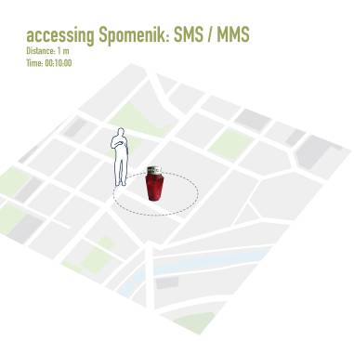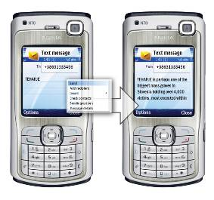
Figure 5. Spomenik 8
If there is no Bluetooth access or if the user wishes instead to use the SMS-based version, the user sends a message to the phone number on the access point with the name of the place. The user is then sent back a message with a story of a victim of that site.

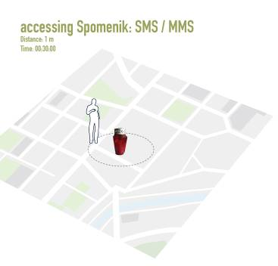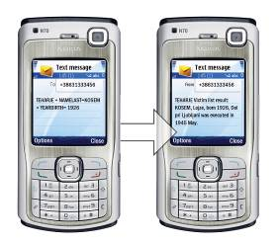
Figure 6. Spomenik 9
Alternately, the SMS access also provides a text based interface to the monument records. In this instance, the user can search to see if someone they were related to was killed there, or perhaps they could just search by surname to see if they potentially had more distant relations killed there.

Conclusion
In this position paper we have briefly highlighted some on-going work in the area of Pervasive Monuments. Spomenik is just one example of how a Pervasive Monument might be built. In particular it has some specific goals. The ideas of blending the physical landscape, with pervasive digital data, so as to reveal almost simultaneously a sense of scale, of social history but also personal narrative are lending themselves to a certain form factor and experience design.
Records of victims have been collected and a front-end web-presence has been created. We are currently in the process of realizing the technological design highlighted above, ready for a public deployment of the monument and attendant study of the associated user experience.

REFERENCES
- Ferenc, M. (2005). Prikrito in Ocem Okrito (Concealed and Hidden From Our Eyes)
- Staniszkis, J, Ontology of Socialism, 131. Cited in Esbenshade, R. S., (1995). Remembering to Forget: Memory, History, and National Identity in Postwar East-Central Europe. Representations, p.80
- Terdiman, R., (1993). Cited in Olick, J. K., Robbins, J., (1998). Social Memory Studies: From “Collective Memory” to the Historical Sociology of Mnemonic Practices. Annual Review of Sociology, p.116
- Noakes, L.. War and Memory: Experiencing the Blitz in London’s Museum. In: Evans, M., Lunn, K., (1997). War and Memory in the Twentieth Century, p.94
- De Certeau, M. Cited in Auge, M., (1995). Non Places, p.173
- Tuan, Yi-Fu, (1977). Space and Place
- Massey, D. (2004). Geographies of Responsibility. Geografiska Annaler, p.7
- Marin, L. (1991). Cited in Auge, M. (1995). Non Places
- Webber, R. (ed.), (2005). Who’s here? Thoughts on Narrative Identity and Narrative Imperialism. Narrative.
- Capps, L., Bonanno, G. A. (2000). Narrating Bereavement: Thematic and Grammatical Predictors of Adjustment to Loss. Discourse Processes, p.18
- Marx, K. (1852). The Eighteenth Brumaire. Cited in Olick, J. K., Robbins, J., (1998). Social Memory Studies: From “Collective Memory” to the Historical Sociology of Mnemonic Practices. Annual Review of Sociology, p.107
- Braid, D. (1996). Personal Narrative and Experiential Meaning. The Journal of American Folklore.

